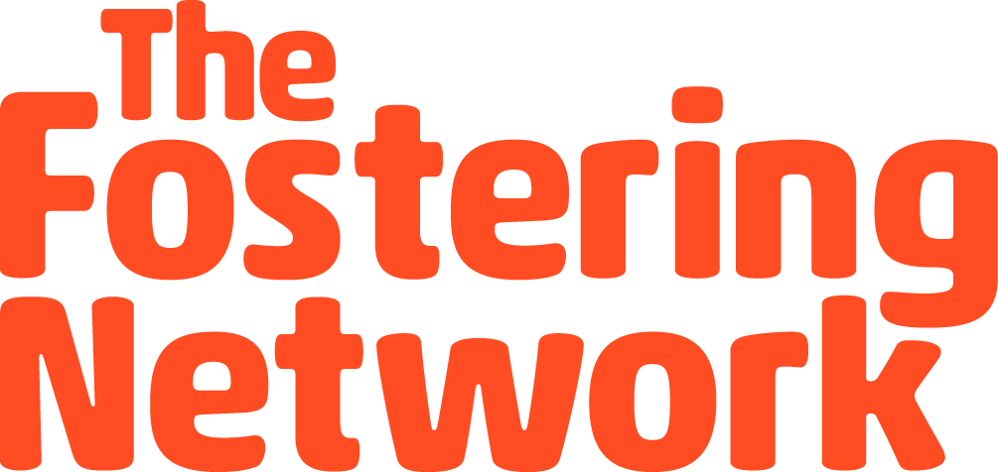

Booking and Consent form

Please return both forms to charlotte.wooders@fostering.net
We would like to come to the event on Sunday 28 January 2018 at Boulders, St Catherines Park, Pengam road, Cardiff, CF24 2RZ.
Foster carer’s full name:
Address:
Postcode:
Telephone number:
Email address:
Who do you foster for?
Young person’s name | Age | Additional needs:  dietary, disability or access

Please note -If there are young people who require additional support this would need to be the case whilst at the event to ensure they get the maximum from the experience. For example, if a child required additional support or 1-2-1 during the school term this would need to be replicated whilst with us. We are happy to discuss and support with this where possible.
*PLEASE ALSO COMPLETE THE CONSENT FORM OVERLEAF*

Consent form

Please read this section with your child and sign below

I understand that …………………………..will be participating in research about looked after children’s experiences of care.
I understand that my child’s participation in this study is entirely voluntary and that they can withdraw at any time without giving reasons. On the day, the researchers will seek verbal consent from my child to take part in the research.
I understand that my child and I are free to ask any questions at any time. If for any reason they experience discomfort during participation, they are free to withdraw. (You and your child can discuss any concerns with The Fostering Network staff.)
I understand that the information provided by my child will be held anonymously and used solely for the purposes of research. However, if my child discloses information regarding harm to themselves or others, the research team will have to report this to the relevant authority.
I understand that in accordance with the Data Protection Act, information collected as part of the research will be retained for a minimum of five years following the completion of the research. No names, addresses or other identifying features will be stored. Information from the interviews may be used in thrive
I, ___________________________________ (Please PRINT name)
give my consent and permission for
_____________________________________ (Print name of child)
to participate in a study conducted by The Fostering Network
Signed Date

